**Semester 2 (Unit 3&4) Examination, 2019**

**Question/Answer Booklet**

**MATHEMATICS METHODS**

**Section Two: Calculator-assumed**

Student Name/Number: ______________________________________________

Teacher Name: ______________________________________________

**Time allowed for this section**

Reading time before commencing work: ten minutes

Working time for this section: one hundred minutes

**Materials required/recommended for this section**

**To be provided by the supervisor:** This Question/Answer Booklet

Formula Sheet

**To be provided by the candidate:**

Standard items: pens (blue/black preferred), pencils (including coloured), sharpener,

correction fluid/tape, eraser, ruler, highlighters

Special items: nil

**Important note to candidates**

No other items may be taken into the examination room. It is **your** responsibility to ensure that you do not have any unauthorised notes or other items of a non-personal nature in the examination room. If you have any unauthorised material with you, hand it to the supervisor **before** reading any further.

**Structure of this paper**

|  |  |  |  |  |  |
| --- | --- | --- | --- | --- | --- |
| Section | Number of questions available | Number of questions to be answered | Working time (minutes) | Marks available | Percentage of exam |
| Section One: Calculator-free | 9 | 9 | 50 | 50 | 35 |
| Section Two: Calculator-assumed | 13 | 13 | 100 | 103 | 65 |
|  | | | | | 100 |

**Instructions to candidates**

1. The rules for the conduct of School exams are detailed in the School/College assessment policy. Sitting this examination implies that you agree to abide by these rules.
2. Write your answers in this Question/Answer booklet preferably using a blue/black pen. Do not use erasable or gel pens.
3. You must be careful to confine your answer to the specific question asked and to follow any instructions that are specified to a particular question.
4. Show all your working clearly. Your working should be in sufficient detail to allow your answers to be checked readily and for marks to be awarded for reasoning. Incorrect answers given without supporting reasoning cannot be allocated any marks. For any question or part question worth more than two marks, valid working or justification is required to receive full marks. If you repeat any question, ensure that you cancel the answer you do not wish to have marked.
5. It is recommended that you do not use pencil, except in diagrams.
6. Supplementary pages for planning/continuing your answers to questions are provided at the end of this Question/Answer booklet. If you use these pages to continue an answer, indicate at the original answer where the answer is continued, i.e. give the page number.
7. The Formula sheet is not to be handed in with your Question/Answer booklet.

**Section Two: Calculator-assumed 65% (103 Marks)**

This section has **(thirteen)** **13** questions. Answer **all** questions. Write your answers in the spaces provided.

Supplementary pages for planning/continuing your answers to questions are provided at the end of this Question/Answer booklet. If you use these pages to continue an answer, indicate at the original answer where the answer is continued, i.e. give the page number

Suggested working time: **100 minutes**.

**Question 10 (5 marks)**

The AFLW teams from Fremantle and West Coast came together to have a kicking competition. Players were given one kick each, to kick as far as they could from a fixed point on the ground. The lengths of the kicks were normally distributed with a mean of 48.9 metres and a standard deviation of 3.8 metres.

(a) Players that kicked the ball longer than 55 metres were invited to take part in a national kicking competition in Adelaide. What percentage of players received this invitation?

(1 mark)

(b) The top 10% of the Fremantle and West Coast players were given a golden boot award to recognise their kicking ability. What distance did these players reach to receive this award?

(1 mark)

(c) If twelve players from the Fremantle and West Coast sides were selected at random, what is the probability that at least seven of the twelve players kicked the ball longer than 45 metres?

(3 marks)

**Question 11 (9 marks)**

(a) Determine the area bounded by the curve $y={\left(3-{2x}^{2}\right)}^{2}-4$ the *x-*axis, the *y-*axis and the line *x* = 2. Give your answer to 3 decimal places. (3 marks)

(b) The graph below shows the functions $f(x) = 3x$ and $g(x) = \frac{x^{2}}{2}$ plus the line $x = 8$ .



Region P is the area enclosed by .

Region Q is the area enclosed by  and $x=8$.

(i) Determine the areas of P and Q. (2 marks)

(ii) $f(x)$ is re-defined such that $f(x) = ax$ and the area of region P is half the area of

region Q. Calculate the value of $a$ that makes this statement true. (4 marks)

**Question 12 (11 marks)**

Engineers investigated a road intersection to determine whether congestion was an issue for motorists.

Traffic density is defined as the number of vehicles per hour that pass a given point on a road. For the intersection in question modelling indicates that congestion is likely to occur if the traffic density exceeds 800 cars per hour.

Vehicle sensors were employed to count and record the number of vehicles passing through the intersection over a 24 hour period. The data were collected on a typical weekday. The results are tabled below.

|  |  |
| --- | --- |
| Number of Vehicles Counted | Number of Hourly Periods |
|  | 1 |
|  | 1 |
|  | 6 |
|  | 6 |
|  | 8 |
|  | 2 |

(a) Use the table above to determine the probability that on a typical weekday

up to 600 vehicles pass through the intersection each hour. (1 mark)

Define the random variable  to take the value 1 if congestion is likely to occur, and the value 0 otherwise.

(b) Complete the probability distribution for  shown below. (2 marks)

|  |  |  |
| --- | --- | --- |
|  | 0 | 1 |
|  |  |  |

(c) State the probability distribution and variance of  (2 marks)

Mel travels through the intersection daily on her way to work, Monday through to Friday.

(d) Determine the probability that Mel is likely to face congestion on at least 2 days in any week. (3 marks)

(e) Determine the probability that in any week, on Thursday, Mel is faced with congestion for the second time in that week. (3 marks)

**Question 13 (8 marks)**

Consider the function  where  and  are constants,  and 

(a) Determine and the - axis intercept for in terms of  and  (2 marks)

(b) On the axes below sketch the graph of  using your answers from (a) above. Label all key features. (3 marks)

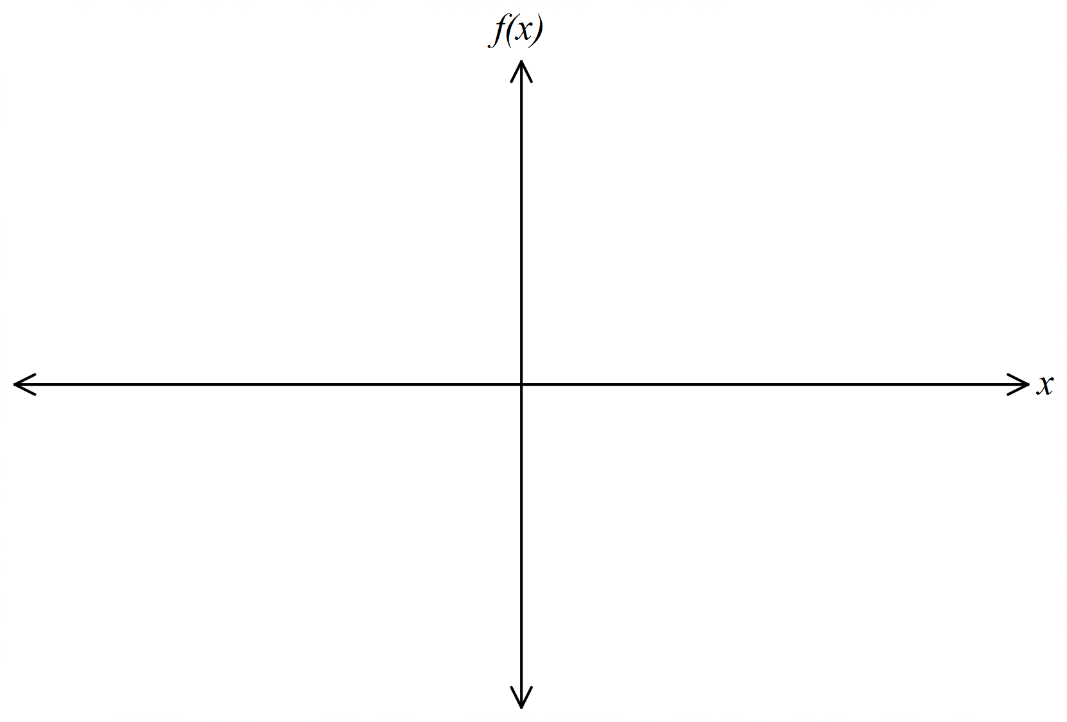

(c) Let  Determine the value of *p* such that 

Interpret this result graphically. (3 marks)

**Question 14 (9 marks) (8 marks)**

The following 95% confidence interval for $p$, the proportion of residents who support a plan to build a commercial theme park in the neighbourhood, has been obtained based on a random sample of residents:

$$0.39<p<0.53$$

(a) What is $\hat{p},$ the proportion of residents in the sample who support the plan? (1 mark)

(b) What is $E,$ the margin of error associated with this confidence interval? (1 mark)

(c) What is $n$, the size of the sample? (2 marks)

(d) The interval $0.42<p<0.50$ is another confidence interval for $p$, based on the same sample. What is the confidence level associated with this second interval? (3 marks)

(e) Opponents of the plan claim that this sampling ‘is compelling evidence that the plan is opposed by a majority of residents’. Is this justified? (2 marks)

**Question 15 (6 marks)**

Theof a solution is a measure of the concentration of hydrogen ions in the solution. The formula to calculate  is

, where  is the hydrogen ion concentration in moles per litre.

A solution is classified as being an acid, base or neutral according to its  value and the following table.

|  |  |
| --- | --- |
| value | classification |
| <7 | acid |
| =7 | neutral |
| >7 | base |

For distilled water the hydrogen ion concentration is  hydrogen ions.

(a) Show that distilled water is neutral. (2 marks)

(b) For ammonia, the  Determine the concentration of hydrogen ions in ammonia. (1 mark)



Given two solutions,  and 

Let = the hydrogen ion concentration of  and let = the  of 

Let = the hydrogen ion concentration of  and let = the  of 

(c) Express  in terms of and. (1 mark)

Thefor Black Coffee is 5 whilst the for Lemon Juice is 2.

(d) Determine the ratio of Hydrogen ions in Black Coffee compared to Lemon Juice.

(2 marks)

**Question 16 (7 marks)**

The graph of the function  contains the point with coordinates .

It has exactly one point of inflection. Furthermore, 

1. Use calculus to locate and classify the stationary points of and to locate its point

of inflection. Give exact answers. (4 marks)

(b) On the axes provided sketch the graph of  labelling all key features.

(3 marks)



**Question 17 (8 marks)**

The plan of a window consisting of a rectangle topped by an equilateral triangle is shown below. The sides of the rectangle are $x$ metres and $y$ metres.

$y$ $y$

$y$

$x$ $x$

$y$

(a) Show that the area $A$ $m^{2}$ of the window is given by

$$A=xy+\frac{\sqrt{3}y^{2}}{4}$$

(3 marks)

(b) Express $A$ as a function of $y$ only, if it is known that the external perimeter of the window is $8$ metres. (2 mark)

(c) Determine the maximum possible area of the window. (3 marks)

**Question 18 (8 marks)**

In this question we determine the probability that the value of a random variable differs significantly from its expected value.

(a) Use your calculator to determine $P\left(\left|X_{1}-μ_{1}\right|≥σ_{1}\right),$ where $X_{1}$ is a normal random variable with mean $μ_{1}$ and standard deviation $σ_{1}.$ (2 marks)

(b) Evaluate the following: (2 marks)

$$\int_{0}^{ 1}{{(x-0.5)}^{2}dx}$$

(c) Use your answer to part (b) to determine $σ_{2},$ the standard deviation of $X_{2},$ where $X_{2}$ is a uniformly distributed random variable whose values lie between $0$ and $1.$ (1 mark)

In part (d) $X_{3}$ is a Bernoulli random variable with parameter $p$. The mean is $μ_{3}$ and the standard deviation is $σ_{3}.$

(d) Evaluate $P\left(\left|X_{3}-μ_{3}\right|≥σ_{3}\right),$ assuming that $p=0.5$ (3 marks)

**Question 19 (6 marks)**

Sports scientists at Cricket Australia have conducted a simulation of a typical Twenty-20 match to determine the number of runs scored off each of the 120 balls.

They intended to examine the number of times a "dot ball" occurred. In cricket, a "dot ball" is when no runs are scored.

The data is recorded below:

|  |  |
| --- | --- |
| Number of runs | Frequency |
| 0 | 36 |
| 1 | 39 |
| 2 | 20 |
| 3 | 3 |
| 4 | 16 |
| 5 | 1 |
| 6 | 5 |

(a) What is the proportion of "dot balls" recorded in this simulation? (1 mark)

(b) Determine the standard deviation for the sample proportion of "dot balls" using the data in the table above. (1 mark)

(c) A confidence interval for the proportion of "dot balls" is to be created from the simulation in the table above. State the margin of error for an 85% level of confidence. (2 marks)

The simulation of 120 balls is repeated another 400 times. The proportion of "dot balls" is recorded each time and placed on a graph. The graph shows the sample proportions on the horizontal axis and frequency on the vertical axis.

(d) Comment on key features of the graph. (2 marks)

**Question 20 (10 marks)**

The position $x cm$ of a mass suspended from a spring at time $t$ seconds is given by the formula

$x\left(t\right)=ae^{-bt}\sin{ct}$ for $t≥0$

where $a,b$ and $c$ are positive constants.

1. Determine the values of $a,b$ and $c,$ correct to $3$ decimal places, given that the mass

first returns to its starting position after $15$ seconds, the initial speed of the mass is

$12 cm s^{-1},$ and the mass is stationary when $t=7$. (5 marks)

(b) Sketch the graph of $x(t)$ for $0≤t≤60$. (2 marks)



(c) Calculate the total distance travelled by the mass in the first $30$ seconds. (3 marks)

**Question 21 (8 marks)**

(a) Elite College is a school which is very proud of their academic results. In their entire

history 35% of students have gained an ATAR of 90 or above. One staff member at the school feels that, in 2019, only 46 out of a sample of 225 students, will achieve an ATAR score which is greater than or equal to 90. The Principal did not agree and said that, “…based on the school’s tradition, this was extremely unlikely.” Was the Principal justified in their comments?

(4 marks)

(b) Edna, the Business Manager at Elite College, was doing a review of the parking and "drop-off" facilities at the school. Presently the school has five parking areas and two "drop-off" zones, which can be used by all types of vehicles. She wanted to make some adjustments to how the school allocated these areas and she decided to conduct some surveys. Comment on the suitability of the following sampling methods and whether they could lead to any bias. Give two valid reasons in each case.

(i) Send a staff member to one car park, selected at random, and interview the

first ten drivers to arrive. (2 marks)

(ii) Send an email to the school community inviting them to answer questions

related to the future of the car parks and "drop-off" zones within the school.

(2 marks)

**Question 22 (8 marks)**

The freight train to a remote desert outpost arrives on a Monday morning every week. It never arrives before 10 a.m. and never arrives after noon. The probability distribution for the time of arrival is given below; $a$ being an unknown constant.

Note: $t$ is measured as minutes after 10 a.m.

$$f(t) = \left\{\begin{aligned}\frac{a}{30}t 0≤t≤120 \\ 0 t<0 or t>120\end{aligned}\right.$$

(a) What is the value of $a$? (2 marks)

(b) What is the probability that the train arrives before 10.30 a.m.? (1 mark)

(c) Given that the train arrives after 11 a.m., what is the probability that the train arrives

before 11.45 a.m. (2 marks)

(d) For the given probability distribution *T,* determine the value of *Var(2T – 1).* (3 marks)

Additional working space

Question number: __________________

Additional working space

Question number: __________________

Additional working space

Question number: __________________

**Acknowledgements**

© MAWA, 2019

This examination is Copyright but may be freely used within the school that purchases this licence.

* The items that are contained in this examination are to be used solely in the school for which they are purchased.
* They are not to be shared in any manner with a school which has not purchased their own licence.
* The items and the solutions/marking keys are to be kept confidentially and not copied or made available to anyone who is not a teacher at the school. Teachers may give feedback to students in the form of showing them how the work is marked but students are not to retain a copy of the paper or the marking guide until the agreed release date stipulated in the purchasing agreement/licence.

*Published by The Mathematical Association of WA*

*12 Cobbler Place, MIRRABOOKA 6061*